PROJECT 4: TWEET SENTIMENT PHRASE EXTRACTION
Ha Thi Nha Linh - 2201140047, Vu Hoai Nhi - 2201140059 and Tran Thi Kim Oanh – 2201140061
Abstract. This report describes fine-tuning a RoBERTa-base Transformer on the Tweet Sentiment Phrase Extraction task. In this context, the problem is set up in an Extractive Question Answering setting: given a sentiment label as the query and a tweet as context, it predicts the sentiment-bearing text span. The proposed model predicts token-level start and end positions and trains using Stratified 3-Fold Cross-Validation. Trained with the AdamW optimizer, experimental results tested with the Character-level F1 metric will show the effectiveness and stability of the proposed approach.
Keywords: Transformer, RoBERTa, sentiment phrase extraction, span prediction.
- Introduction
Traditional sentiment analysis tasks are primarily concerned with sentence- or document-level classification and lack explainability regarding the elements of the input that are indicative of the expressed sentiment. Tweet Sentiment Phrase Extraction is concerned with closing the gap by identifying the precise element of the input that is indicative of the expressed sentiment.
The problem can easily be reduced to an Extractive Question Answering problem with the sentiment label as the question, and the text in the tweets as the context. The excellent span modeling performance of the RoBERTa variant brought about the motivation to fine-tune a RoBERTa-base model on the problem of span prediction of the sentiment using the start and end span indexes.
The main contributions of this work are:
- The job of sentiment phrase extraction as a span prediction task using RoBERTa.
- Applying Stratified 3-Fold Cross Validation for stable evaluation across sentiment classes.
- Assessment of fine-tuning methods and results of performance on the Character-level F1.
- Data and Preprocessing
  - Metadata Description
In this dataset, there are roughly 27,500 tweets for training, where each tweet has its text, sentiment polarity (positive, negative, or neutral), and corresponding selected text (selected_text). In consideration of stable model convergence, missing data in text and selected_text were imputed by an empty string. Then, in instances having neutral sentiment polarity, selected_text was populated with the content of text since it should be selected in its entirety for lack of particular phrases reflecting emotional context.
  - Tokenization and Encoding for Span Extraction
The sentiment phrase extraction is posed as an Extractive Question Answering task, where the sentiment label is used as a question and a corresponding text is referred to as the context. The input sequence is built by concatenating both the text and question using special tokens by maintaining a fixed maximum of 96 tokens via the RoBERTa tokenizer.
For span prediction tasks, the ground truth annotations are changed from the character level to the token level using the offset mapping of the tokenizer, indicating the characters' offset values for each token. Thus, the mapping of the offset values with the ground truth annotation for the sentiment phrase gives the token indices representing the span boundaries that the model predicts at the token level but is trained on the F1 score at the character level.
- Model and Fine-tuning Techniques
  - Model Architecture for Span Prediction
The underlying core encoder for the RoBERTaSpanExtractor model is a pre-trained RoBERTa-base architecture. The Transformer's final hidden states are treated as features by incorporating two task-specific output components to adapt this model for the sentiment span extraction task:
- Dropout Layer (p=0.1): Applied on the final hidden representations to avoid overfitting and improve generalization.
- Span Prediction Heads: it uses two different linear layers to predict start and end token logits of the sentiment-bearing phrase.
Formally, given the final hidden states $H∈R^{T×768}$ where the sequence length is represented by T, the model computes:
start_logits = $HW_{s}$, end_logits = $HW_{e}$
where $W_{s}$, $W_{e}$ $ϵ{ R}^{768x1}$ are learnable weight matrices. The logits are then normalized by a softmax operation over the token dimension to yield probability distributions. This architecture permits the model to assume independence in the likelihood of each token regarding whether it forms the start or end of the target sentiment span, a standard assumption in extractive QA formulations.
  - Training and Optimization Strategies
To facilitate the stable convergence and fine-tuning, the following approaches were used:
- Loss Function: The training objective is to minimize the sum of two cross entropy losses for predicting start and end points.
$L$ $= L_{start}+ L_{end}$
- Optimizer: The used optimizer is AdamW. The learning rate for training remains at $LR=3×{10}^{-5}$. The use of AdamW in Transformer models is appropriate due to its correct decoupling of weight decay during update.
- Regularization through Layer Freezing: To ensure that training is stable and prevent overfitting problems from arising, the parameters of the initial two layers of the Transformer encoder were frozen. It helps in retaining low-level linguistic features and allowing upper layers to adjust according to task-specific semantics.
  - Evaluation via Stratified Cross-Validation
A Stratified 3-Fold Cross-Validation (CV) technique was used to ensure that the number of examples for each sentiment category is relatively equal for all folds. The model was trained for three epochs on each fold and the validation accuracy was evaluated after each fold is completed. This type of validation is known for providing a good approximation of the model’s generalization ability on new and unseen data.
- Results, Analysis, and Evaluation
  - Training Dynamics and Loss Convergence
The fine-tuning process showed stable convergence for all three cross-validation folds. The decrease in the loss shown in the training loss graphs indicates that the model learned span boundary representations successfully within a small training period since the loss reduced steadily from a value of approximately 2.25 → 1.45 in Fold 1, 2.20 → 1.40 in Fold 2, and 2.22 → 1.41 in Fold 3. The stability demonstrates the success of the AdamW optimizer and partial layer freeze.
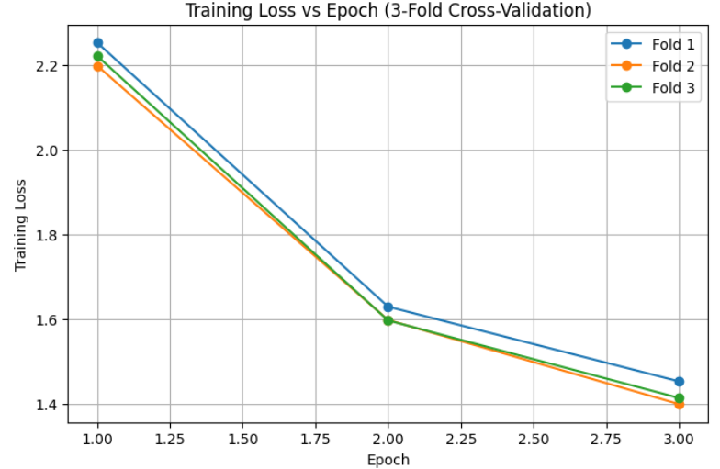
Fig. 1. Training Loss vs Epoch across 3 folds
  - Character-level F1 Performance Analysis
4.2.1 Quantitative Results (Character-level F1)
The Char-F1 score is the the score assigned by the Character-level F1 metric based on the overlap between the predicted and actual spans of the sentiment for each character in the sentence.
The Char-F1 score for the 3-fold validation is 0.6324 on average. However, the score for each fold is 0.6293, 0.6721, and 0.5958 for fold 1, fold 2, and fold 3, respectively. The small variance shows the high robustness of the
Inference involved several post-processing heuristics that were lightweight, such as correcting start and end indexes and limiting span length to 15. These were necessary because of invalid span predictions.
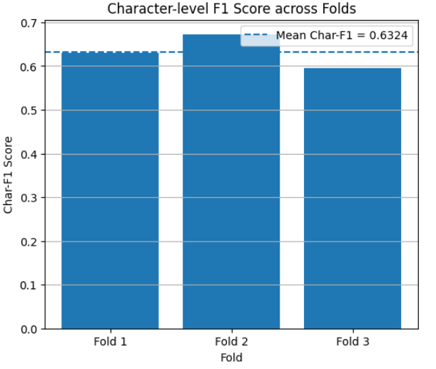
Fig.2. Character-level F1 score per fold
4.2.2 Qualitative Inference Examples
For the purpose of a qualitative analysis of the trained model on the test data, a few examples from the test data are chosen. These examples relate to the capability of the model to accurately locate phrases containing sentiment in the different classes of sentiment.
Sentiment | Tweet text | Predicted selected text
Positive | thats so cool | thats so cool
Negative | I THINK EVERYONE HATES ME ON HERE lol | HATES
Neutral | about to go to sleep | about to go to sleep
Table 1. Inference Examples on New Data
  - Critical Analysis of Neutral Sentiment
Handling the neutral samples requires special attention. Based on the definition of the task, the overall perfect prediction of the tweet results in a perfect F1 score on the Neutral samples, leading to a higher Character-level F1 score. However, the Negative and Positive samples are easier due to the need for accurate boundary identification.
The confusion matrix in this analysis only captures the distribution of the sentiment labels in the dataset and not any prediction errors on the part of the model because the model is not a sentiment classifier. The aim of the confusion matrix is to underscore how much the majority class of examples in the dataset is the "Neutral" examples.
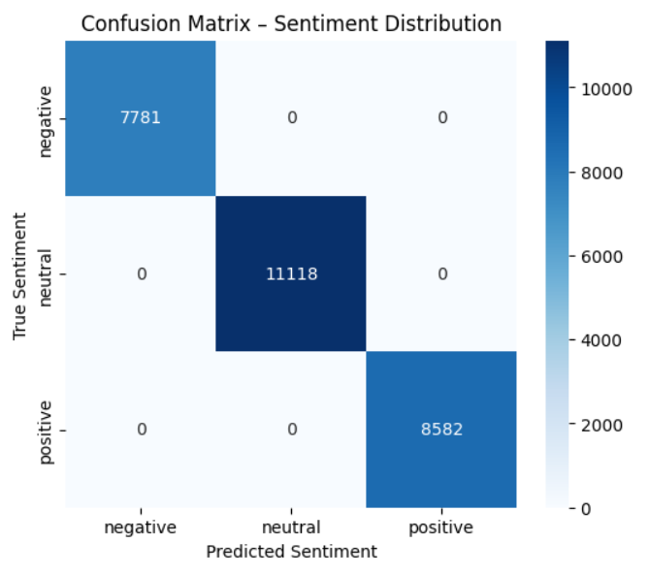
Fig.3. Sentiment distribution (Confusion Matrix)
  - Model Limit
Despite stable performance, there are still several limitations:
- Non-joint learning: The model uses gold sentiment labels and performs non-joint learning of sentiment and span prediction, which decreases robustness to incorrect instances of the data.
- Heuristic dependence: The dependence on heuristics for post-processing suggests that there exist remaining vulnerabilities in the original token-level predictions.
- Conclusion and Future Works
This paper has shown the efficacy of fine-tuning the RoBERTa-base model using span prediction formulation for Tweet Sentiment Phrase Extraction tasks. The designed system was able to attain an average Character-Level F1 score of 0.6324 with strong generalization ability using Stratified 3-Fold Cross-Validation.
In the future, enhancing the model may involve learning jointly the classification of sentences into sentiment and the corresponding span extraction task, exploring the use of decoding constraints to suppress the prediction of invalid spans, or using a larger Transformer model or a domain-adapted model.

